EduTutor AI: Personalized Learning With Generative AI And LMS Integration

**Team Members** :

GAIRABOINA TIRAPATHAIAH

GONISAPUDI SAI KUMAR

GOVADA MURAIL VENKATA SIVA SAI KRISHNA

GUMMA HARI PRAKASH

KAKUMANU DURGAPRASAD

Faculty Mentor: Manoj

# 1. Introduction

Edututor AI refers to a modern, intelligent approach to personalized education that emphasizes adaptivity, automation, integration, and continuous learning enhancement. It harnesses generative AI technologies and learning management system (LMS) integration to optimize each phase—content creation, delivery, engagement, assessment, and feedback—for more personalized, scalable, and impactful learning experiences.

**2. Tools & Technologies**

* Python 3, FastAPI / Flask (Backend orchestration)
* HTML, CSS, JavaScript (AJAX) for responsive LMS UI components
* VS Code (Development Environment)
* Replit / Render / Azure App Services for cloud deployment

**3. Technical Architecture**

The system consists of a front end interface (HTML/CSS/JS) where the user types a query. The back end is a Flask server that sends the user query to the IBM Granite model via Open AI- compatible API, fetches the response, and returns it to the user in real time.

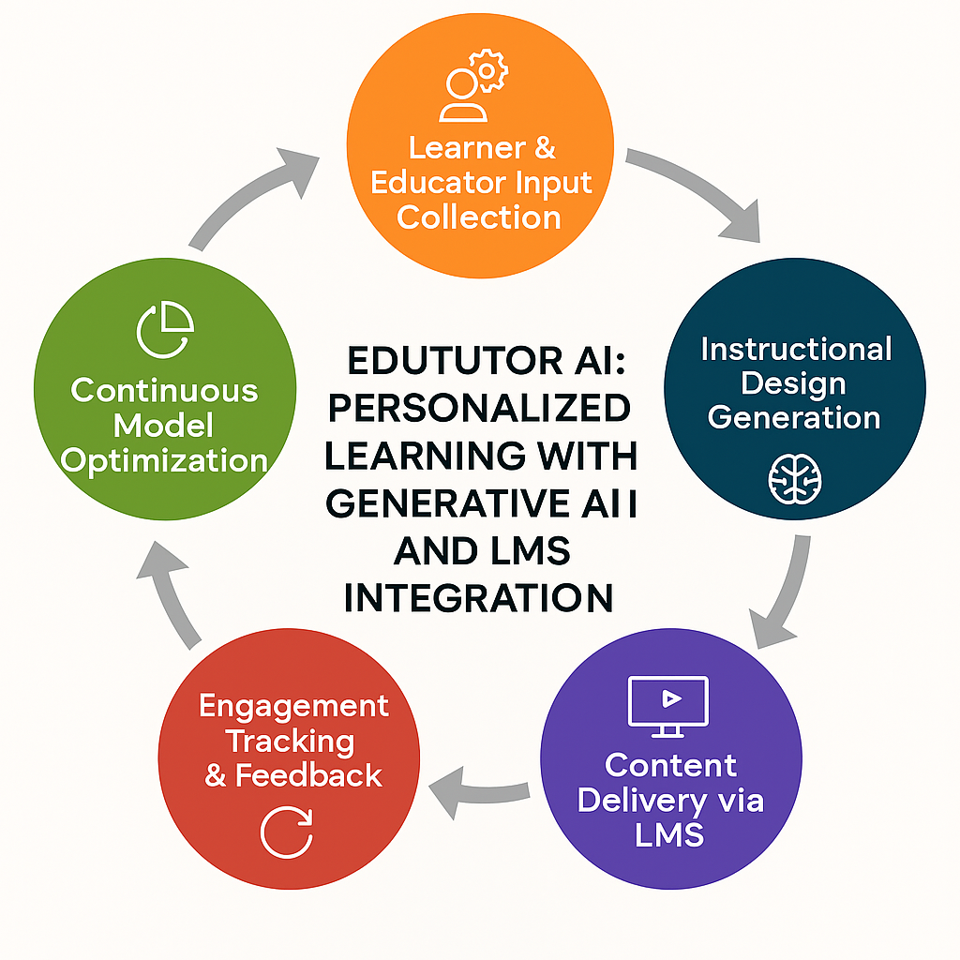

# 4. Modules Implemented

# Core Functionality: AI-driven lesson plan, quiz generation, and feedback based on student input and learning goals.

# Application Logic: FastAPI handles the orchestration layer, API requests, and LMS integration workflows.

# UI Design: Responsive, role-based dashboard interface for students and instructors, integrated with LMS.

# Deployment: Easily deployable on platforms like Replit, Render, or cloud services such as Azure or AWS.

# 5. Sample Code Snippet

import openai

response = openai.ChatCompletion.create(

model="gpt-4",

messages=[

{"role": "system", "content": "You are an AI tutor that generates personalized educational content."},

{"role": "user", "content": user_input}

]

)  
**6. Output (Demo)**

Starting interface of the Website:

*

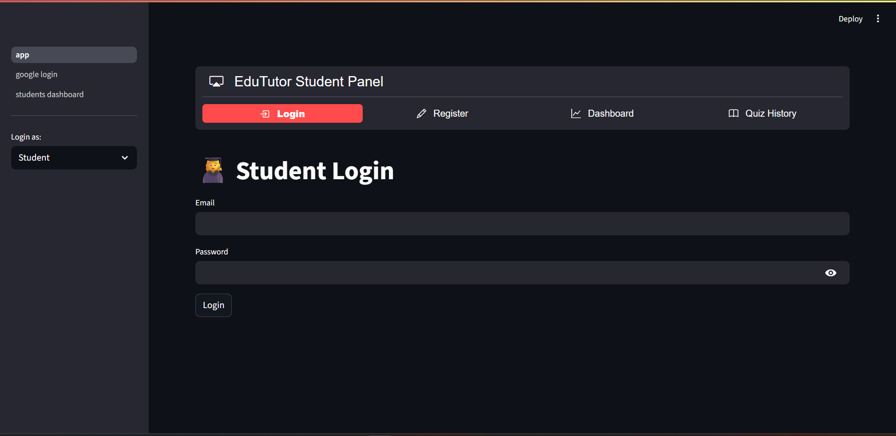

# 

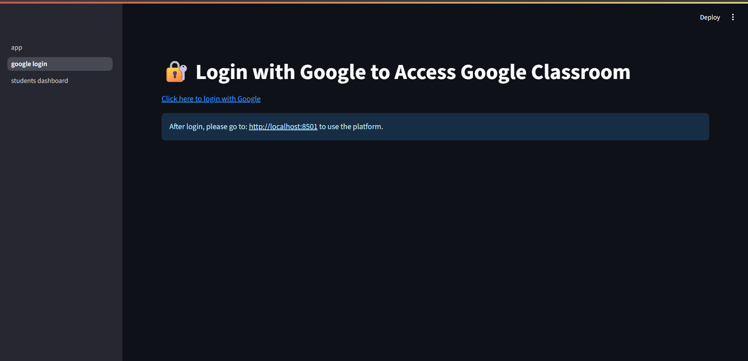

# 7. Advantages & Disadvantages

Advantages:

* Personalized Learning Experience
* Automated Content Generation
* Real-Time Feedback & Analytics
* Seamless LMS Integration
* Scalable Across Institutions

Disadvantages:

* High Initial Setup & Training Cost
* Integration Complexity with Legacy Systems
* Dependency on AI Accuracy & Data Quality
* Data Privacy & Security Concerns
* Requires Technical & Pedagogical Expertise

# 8. Conclusion

The Edututor AI platform represents a significant advancement in the transformation of digital education by integrating generative AI-powered intelligence into each phase—from personalized content creation to adaptive delivery, student engagement, assessment, and real-time feedback.  
Overall, Edututor AI not only enhances learning quality and instructor efficiency but also lays the foundation for future innovations like multi-modal learning, intelligent tutoring systems, institutional analytics, and scalable cloud-integrated classroom solutions.

**9.Future Scope**

* Add multilingual support
* Connect with telemedicine services
* Integrate voice input and wearable data

# Apendix

* **Source Code:** Included
* **Dataset Link:** OpenAI / Azure OpenAI documentation and LMS sample datasets
* **GitHub & Demo Link:** [GTirapathaiah/Edututor-Ai-Personalized-Learning-With-Generative-Ai-And-Lms-Integration: EduTutor AI: AI-powered personalized learning with IBM Watsonx, Google Classroom, and Pinecone for smarter education.](https://github.com/GTirapathaiah/Edututor-Ai-Personalized-Learning-With-Generative-Ai-And-Lms-Integration)